1. ­­Before running the script, make sure you have an excel file called pix_trans_resend.xlsx in your default downloads folder on Windows.
2. Ensure that the following column names are the exact same, although the order of the columns doesn’t matter except the last one “Status” has to be the last column.
   1. Graphical user interface, table

      Description automatically generated
3. The date format should be in some kind of xx/xx/xxxx xx:xx format. The script is able to ignore the BRT part. The script will convert the date accordingly to input so you don’t have to worry about the order of the day and month.
4. The status column should be blank for any pix transactions numbers you want to resend.
5. Make sure that the excel file is closed before running the script.
6. To run the script, navigate to the Resend_PIX_Transactions_Script.exe file where you have it stored and simply double click it to run the program. You do not need to do anything else as the program is running.
7. The script will go through the process of resending the pix transactions.
8. When running the script, it will open a black console window where it will print out statements describing what it is currently doing. It will create a new chrome window where it will state that its being run by automated test software as seen below. The script runs in the background independently, simulating the clicks and key presses, but it doesn’t take control of your computer, allowing you to continue other work. Although to be extra safe, you should just let it run without doing anything else.
   1. Graphical user interface, text, application

      Description automatically generated
   2. When running the program, the console will something like this. If you see some strange errors involving not being able to connect to Bluetooth or devices, then that is normal.
   3. If you receive an IndexError about it being out of bounds like below then that just means the status column has been completely filled and there needs to be more rows of pix transaction numbers to resend with the status column being blank.
   4. The error about the unknowntimezonewarning like below you can ignore.

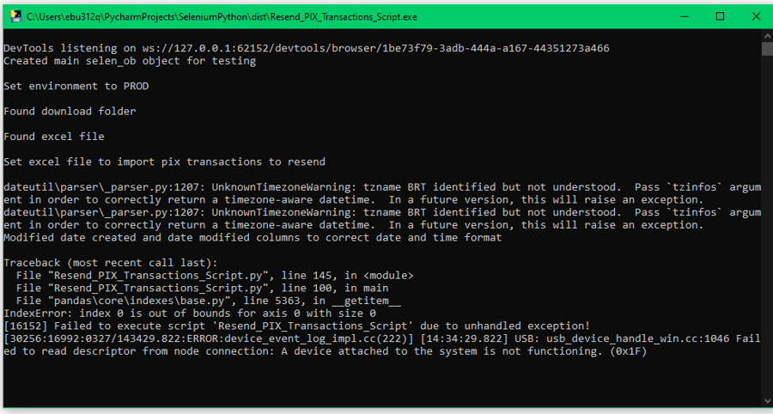

1. ***If you want to stop the script then just close the browser window or the console window. It will take a few seconds for it to fully close.******Even though you stopped the script it will still remember all the pix trans numbers you resent so far and if they passed or not. So if you check the pix_trans_resend.xlsx file again, it will show you that. So you can just run the script again and it will continue on from where it left off.***
2. If the script finishes completely through the whole excel file or you stopped the script manually, the console will say something like “SCRIPT HAS FINISHED RUNNING”, then it will update the status column in the pix_trans_resend.xlsx automatically.
3. Also, after it finishes running or if you stop the script, it will export an excel file to a Script Results folder in your C:\ within another folder with the date as month-day-year and the excel file itself will have the time at the end of its filename as hour-minute-second (in 24 hour format).
   1. 
   2. 
4. In the results file there will be 2 sheets, Script Results, Data
   1. Script Results will list out each step that the script performed and if it passed with detail as to which element on screen it was interacting with. If the script times out, it will still export an excel file and the last step listed in the Script Results sheet was the last step it did.
   2. The Data tab is basically a copy of what is added into the Status column of pix_trans_resend.xlsx.
5. The script is very consistent in running, so you shouldn’t encounter too many errors, unless the web elements of MH have changed in some way or the script was too fast or too slow to detect a web element which are the most possible errors that could happen. If you encounter the script consistently failing at detecting a certain element, then please let me know by sharing the excel file that is outputted in the c drive.
6. The script is able to handle if “No data is found” popups after you search or if it’s unable to find the transaction number. In both cases it will keep moving on and then indicate those things in the status column for the respective transaction number.